March Mathness Worksheet 1
Introduction to Excel, Udemy, and Ranking
Due: Midnight Thursday January 28^{tt}

In this activity, we will lay the groundwork and give you the tools for our activities moving forward. First, our ongoing activity will be to follow your assigned conference. We will be practicing our ranking methods on your respective conferences. We will also be using the educational platform Udemy. At the end of this module, we will walk you through the process to set up an account and enroll in the preselected course.

- Here is a list of the 32 Division-1 NCAA Men’s Basketball conferences, as mentioned, your TA will be using the ACC as an example as you move through the modules( the number of teams in the conferences are shoen in brackets) :

- America East Conference (9)  - American Athletic Conference(AAC)(11)  - Atlantic 10 Conference (A10) (14)  - Atlantic Coast Conference (ACC) (15)  - Atlantic Sun Conference (A-Sun) (8)  - Big 12 Conference (10)  - Big East Conference (10)  - Big South Conference (11)  - Big Sky Conference (12)  - Big Ten Conference (14)  - Big West Conference (9)  - Colonial Athletic Association (10)  - Conference USA (C-USA) (14)  - Horizon League (10 )  - Ivy League (8 teams)  - Metro Atlantic Athletic Conference(MAAC)(11) | - Mid-American Conference (MAC) (12)  - Mid-Eastern Athletic Conference (MEAC)(13 )  - Missouri Valley Conference (MVC) (10)  - Mountain West Conference (11)  - Northeast Conference (10)  - Ohio Valley Conference (12)  - Pacific-12 Conference (Pac-12) (12)  - Patriot League (10)  - Southeastern Conference (SEC) (14)  - Southern Conference (10)  - Southland Conference (13)  - Southwestern Athletic Conference(SWAC)(10)  - Sun Belt Conference(11)  - The Summit League(9)  - West Coast Conference (WCC)(10)  - Western Athletic Conference (WAC)(8)

As a point of reference, the Atlantic Coast Conference (ACC), Big East Conference, Big 12 Conference, Southeastern Conference (SEC), Pacific 12 Conference (Pac 12), and the Big Ten Conference have sent the most teams to the NCAA tournament in its history. For more information on Tournament history by Conference, you can refer to this page: http://en.wikipedia.org/wiki/NCAA_Men%27s_Division_I_Tournament_bids_by_school_and_conference . I’ve included the conference abbreviations with some of the more popular/competitive conferences. You’ll see these abbreviations used often as you read ESPN or other sports-news sites.

- When you choose your conference for the project, this will be YOUR conference this basketball season. You can decide to know as much or as little about it as you like, but you will be expected to, at the very least, keep a record of games played between your conference members. These games constitute “Conference Season”. In fact, conference season has already begun for every conference, so we already have some work to do in familiarizing ourselves with our conferences. Our primary objective is to record the number of times Team A plays Team B in your conference, and the # of total games, wins and losses for each team in your conference. We’ll eventually add these numbers to our mathematical ranking model, but we’ll get to that in the coming weeks. For now, we’ll simply record our conference data in Excel. To start, visit this ESPN page, find your conference, and then go to Conference Standings.

- Open Excel. Create two tables in Excel, one will show each team’s games played, wins, and losses. The second will show how many times each team plays another team.

- In table one, create columns for “Team”, “Total Games”, “Wins”, and “Losses”. Each Row should be a team in your conference. This data can be easily found on the ESPN page. Be sure to only include wins and losses from conference play. These will be less than the overall wins and losses.

- For the second table, let each row and column be the team in your conference. At the intersection of Team A and Team B, list the number of times that Team A played team B. At the intersection between Team A and Team A or between Team B and Team B, list 0. It should look something like this:
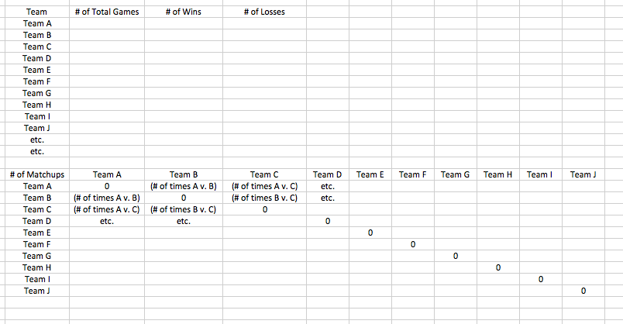

This is an example of what it should look like from 2014’s ACC play (through 1/12):
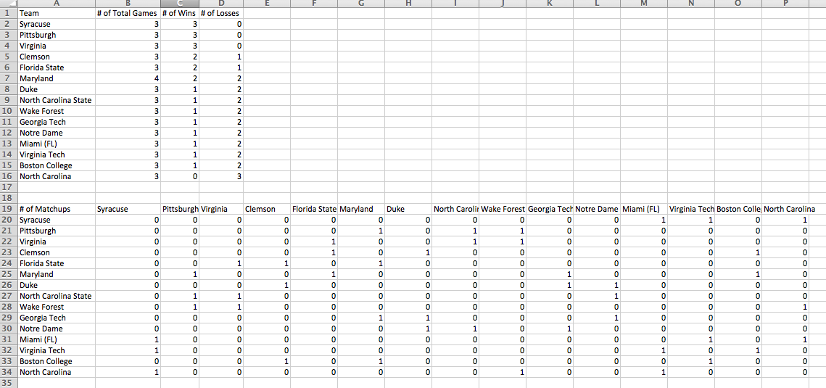

- We will use the data from this spreadsheet later in the course, but you should keep this data updated throughout conference season.

- Now, we will log in to the Udemy course we will be using in conjunction with this project. Please go to https://www.udemy.com/march-mathness/ and click “start learning now free”

- Create an account by following the steps Udemy provides. After you’ve registered, click “Go to Course page”

- Watch Lectures 1, 2, and 3 of the course by Tim Chartier (a total of about 10 minutes).

Assignment:

- Create the two tables in Excel for your conference substituting in the correct team names, and fill out both tables up to and including games for Sunday, January 17th. Email this spreadsheet to your TA by the due date.
- Write up a paragraph detailing what you knew about your assigned conference before doing any research, what you found most interesting from the Tim Chartier lecture. Submit this with your spreadsheet to your TA.

